B.Sc. I.T. SY SemesterIV

SOFTWARE TESTING & QUALITY ASSURANCE

MANUAL FOR PRACTICALS

2022 - 23

Course Code: US-SIT-4P3
Practical III Software Testing and Quality Assurance Total Credits: 2

1 Evaluating Test Exit Criteria and Reporting
2 Static and Dynamic Analysis
3 Rate Quality Attributes for Domain and Technical Testing
4 Perform Review
5 Incident Management
6 Path Testing and Equivalence Partitioning
7 Performance Testing
8 Using Testing Tool Selenium
9 Using Testing Tool QTP(QuickTest Professional) / UFT(Unified Functional Testing.)
10 Using Testing Tool WAPT

INDEX
SR.  NO. | PARTICULARS | DATE | PG.  NO. | SIGNATURE
1. | Evaluating Test Exit Criteria and Reporting
2. | Static and Dynamic Analysis
3. | Rate Quality Attributes for Domain and Technical Testing
4. | Incident Management
5. | Path Testing and Equivalence Partitioning
6. | Perform Review
7. | Performance Testing
8. | Using Testing Tool Selenium
9. | Using Testing Tool AutoIT

PRACTICAL 1

Evaluating Test Exit Criteria and Reporting

Problem Statement:
1. What are the various properties of test execution process to measure completeness of testing and reporting?
2. What type of worksheet can be used to track the number of important properties of test execution?
3. Write a test plan in IEEE 829 format.

Solution:
Answer 1:
- Number of test conditions, cases, or test procedures planned, executed, passed, and failed.
- Total defects, classified by severity, priority, status, or some other factor
- Change requests proposed, accepted, and tested
- Planned versus actual costs, schedule, effort
- Quality risks, both mitigated and residual
- Lost test time due to blocking events
- Confirmation and regression test results

Answer 2 :
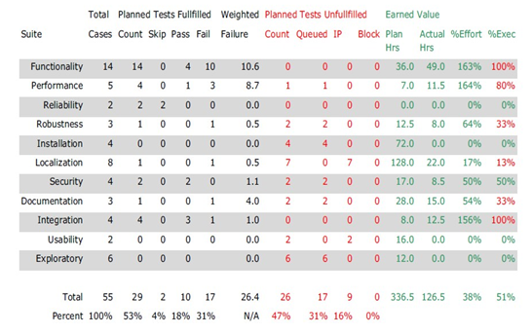

Answer 3:

Test Plan According to IEEE 829
- Test Plan Identifier
Specify uniquely the name and version of the test plan. A standard for document identification is often given by rules set by the project manager or by the organization's central document management. The minimum components to be used are the name of the test plan, its version, and its status.

- Introduction
The introduction should give a short summary of the project background. These typically include policies and standards, such as industry standards, company standards, project standards, customer standards, the project authorization (possibly the contract).

- Test Objects or Items a short overview of the parts and components of the product to be tested; identify the test items including their version/ revision level. There should be a list of what is not subject to testing.

- Features to be tested
This section should identify all functions or characteristics of the system, which should be tested.

- Features not to be tested
In order to avoid misunderstanding and prevent unrealistic expectations, it should be defined which aspects of the product shall not or cannot be tested.

- Test Approach or Strategy
Describe the test objectives, if possible, based on risk analysis. The analysis shows which risks are imminent if faults are not found due to lack of testing.

- Acceptance Criteria
After all tests for a test object have been executed, it must be determined, based on the test results, if the test object can be releasedand delivered. Acceptance criteria or test exit criteria are defined to achieve this.

- Suspension Criteria and Resumption Requirements
Aside from acceptance criteria, there is also a need for criteria to indicate a suspension or termination of the tests.

- Test Deliverables
In this section we describe which data and results every test activity will deliver and in which form these results are communicated.

- Testing Tasks
This section is a list of all tasks necessary for the planning and execution of the tests, including assignment of responsibilities.

- Test Infrastructure and Environmental Needs
This section lists the elements of the test infrastructure necessary to execute the planned tests.

- Responsibilities
How is testing organized with respect to the project? Who has what authority and responsibility?

- Staffing and Training Needs
This section specifies the staffing needs (roles, qualifications, capacity, and when they are needed, as well as planning vacations, etc.). Training for providing necessary skills should be included.

- Schedule
An overall schedule for the test activities is described here, with the major milestones. This plan must be coordinated with the project plan and maintained there. Regular consultation between the project manager and the test manager must be implemented.

- Risks and Contingencies
In the section about test strategy, risks in the test object or its use are addressed. This section, however, addresses risks within the testing project itself, i.e. risks when implementing the test concept, and risks resulting from not implementing reasonable activities, because there are no resources for them in the concrete project.

- Approvals
This section should contain a list of people or organizations that approve the test plan, review it, or at least should be informed about it.

- Glossary
Testing has no tradition for using standardized terminology. Thus, the test plan should contain an explanation of the testing terms used. There is a high danger that different people will have different interpretations of test terminology.

IEEE829 format

